Requirements model for Final Project - Phase 1 submission: **50 points**

1. Install JavaFX plugin into Eclipse as per the **JavaFX installation SP 18** doc file.
2. Create a JavaFX project as per the **JavaFX installation SP 18** doc file.
3. In your project folder create any relevant classes (including some relevant data members & method member [*stubs*](https://en.wikipedia.org/wiki/Method_stub)) and any interfaces for your project domain. Absolutely no coding is needed at this time.

Sample “**rough” UML sketch of a Domain for a Bank**

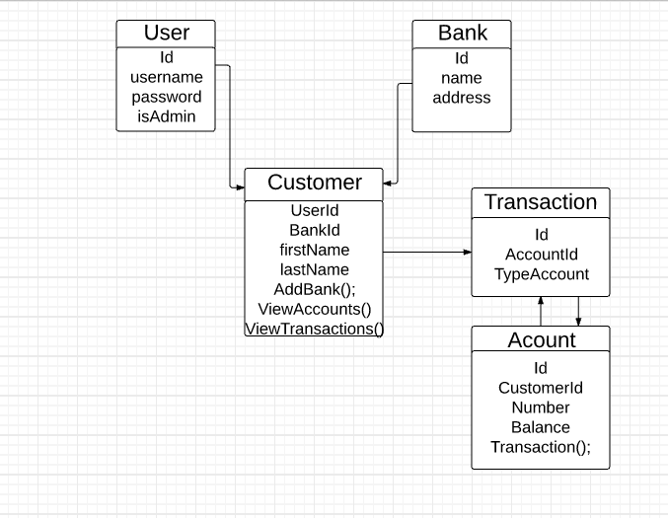

Project Objectives

The task, when creating your model/design is to mainly think logically about the functionalities that your system can perform based on various user roles.

Project Deliverables

1. Inlude a minimum 4 classes (2 *additional* classes for a team of 2) in your model where one class will serve as the base class and two classes will serve as subclasses for the base class.
2. Include at minimum one interface with at least one implementation.

Note your idea should not include the bank domain demoed during classtime.

1. Finally create a UML diagram for phase I credit and submit your project for grading. Follow the instructions as per the **UML processing SP 18** doc file to get you started

with working UML in Eclipse and submitting your work to Blackboard.

Your TA will check over your model, provide support for any modeling questions, and after approval you can proceed to phase II which will entail the implementation of your project using JavaFX and a MySQL database.